CS 449/649 Assignment Template
1st Student Name  Department  uwaterloo e-mail address | 2nd Student Name  Department  uwaterloo e-mail address | 3rd Author Name  Department  uwaterloo e-mail address

SECTION 1
I’m doing my assignment.

SECTION 2
Say something here. Say something here. Say something here. Say something here.

Subsection 2.1
Say something here. Say something here. Say something here. Say something here.

Sub-subsection 2.1.1
Say something here. Say something here. Say something here.
Subsection 2.2
Say something here. Say something here. Say something here. Say something here.

Figure 1. Number all figures and include captions below, using Insert, Caption.

SECTION 3
Use a numbered list of references at the end of the article, ordered alphabetically by last name of first author, and referenced by numbers in brackets [1,3,4].

Objects | Caption – pre-2002 | Caption – 2003 and afterwards
Tables | Above | Below
Figures | Below | Below
Table 1. Table captions should be placed below the table. We recommend table lines be 1 point, 25% black. Minimize use of unnecessary table lines.

Inserting Images
Occasionally MS Word generates larger-than-necessary PDF files when images inserted into the document are manipulated in MS Word. To minimize this problem, use an image editing tool to resize the image at the appropriate printing resolution (usually 300 dpi), and then insert the image into Word using Insert | Picture | From File.

Conclusion
Say something here. Say something here. Say something here. Say something here. Say something here. Say something here. Say something here. Say something here. Say something here. Say something here. Say something here. Say something here. Say something here. Say something here. Say something here. Say something here. Say something here. Say something here. Say something here. Say something here. Say something here. Say something here. Say something here. Say something here. Say something here. Say something here. Say something here. Say something here. Say something here. Say something here.

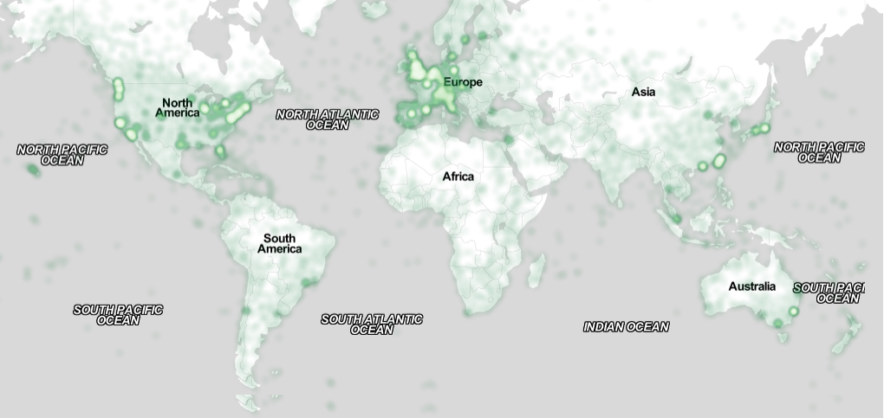
Figure 2. Sample of a wide figure. Be sure to place at the top or bottom of the page. Ensure that important information is legible in both black-and-white and color printing. Image: CC-BY-ND ayman on Flickr.

REFERENCES

- Ronald E. Anderson. 1992. Social impacts of computing: Codes of professional ethics. Soc Sci Comput Rev 10, 2: 453-469.
- Anna Cavender, Shari Trewin, Vicki Hanson. 2014. Accessible Writing Guide. Retrieved August 22, 2014 from http://www.sigaccess.org/welcome-to-sigaccess/resources/accessible-writing-guide/
- Morton L. Heilig. 1962. Sensorama Simulator, U.S. Patent 3,050,870, Filed January 10, 1961, issued August 28, 1962.

